Name-Anmol yadav

SAP ID -500083814

BATCH- DevOps

**EXPERIMENT 5**

**AIM: Working with Dockerfile to Build and Push Docker Image**

**Steps to Complete:**

1. Create Dockerfile

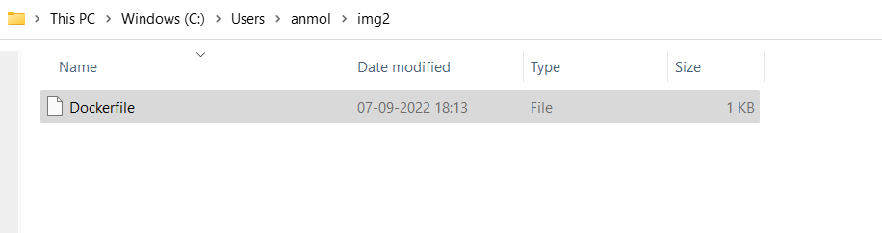

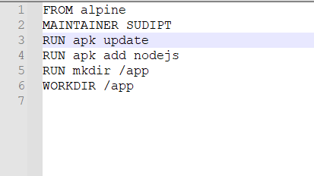

1. Now we have dockerized the app, we will Build image from Dockerfile.

**Command:** **docker build –t myimage:0.1** .

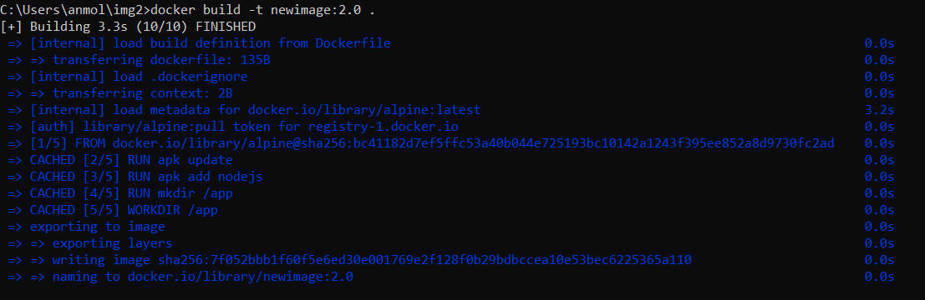

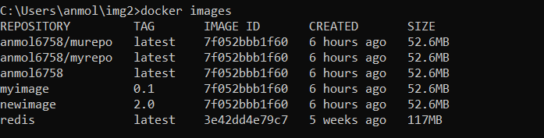

1. Create account on Dockerhub and create a repository in it.

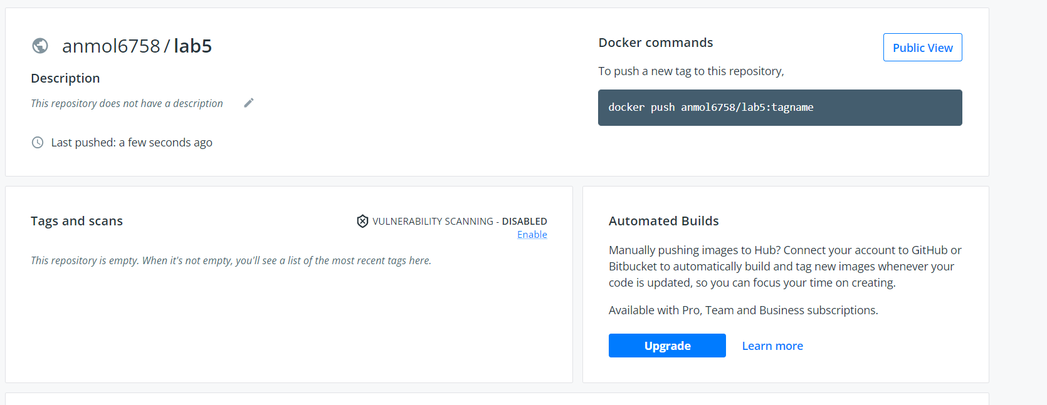

1. Tag the recently created image using following command.

# **Command: docker tag imageID Repositoryname**



1. Login to Dockerhub from console using following command.

**Command: docker Login**

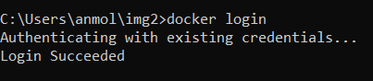

1. Now push the image on Dockerhub using following command.

**Command: docker push Repositoryname**

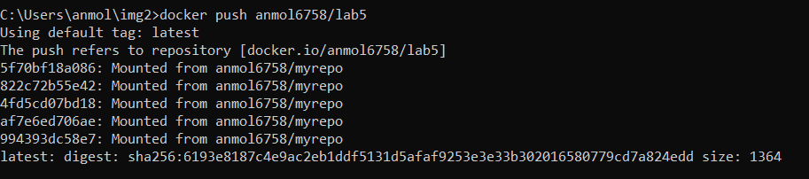

1. Pull and Run the container of your deployed image on docker hub.

# **Command:Docker run -d image_name**

